**Job Explorer System**



## By:

### Farsan khan

**22522**

### Saud Akbar

**22661**

### Shahzaib Ishaq

**30041**

**Supervised by: Mr.Shahzad Ahmad khan**

## Faculty of Computing

**Riphah International University, Islamabad FALL 2024**

### A Dissertation Submitted To

**Faculty of Computing,**

### Riphah International University, Islamabad

**As a Partial Fulfillment of the Requirement for the Award of the Degree of**

### Bachelors of Science in Software Engineering

#### Faculty of Computing

**Riphah International University, Islamabad**

Date: Mar 21, 2024

#### Final Approval

This is to certify that we have read the report submitted by ***Farsan khan (22522), Saud Akbar (22661), Shahzaib Ishaq (30041)*** for the partial fulfillment of the requirements for the degree of the Bachelors of Science in Software Engineering (BSSE). It is our judgment that this report is of sufficient standard to warrant its acceptance by Riphah International University, Islamabad for the degree of Bachelors of Science in Software Engineering (BSSE).

**Committee:**

|  |
| --- |
| **1** |
| Mr.Shahzad Ahmad khan (Supervisor) |
| **2** |
| Dr. Musharraf Ahmed (Head of Department) |

## Declaration

We hereby declare that this document “**Job Explorer System”** neither as a whole nor as a part has been copied out from any source. It is further declared that we have done this project with the accompanied report entirely on the basis of our personal efforts, under the proficient guidance of our teachers especially our supervisor **Mr.Shahzad Ahmad khan**. If any part of the system is proved to be copied out from any source or found to be reproduction of any project from anywhere else, we shall stand by the consequences.

##### Farsan khan 22522

**Saud Akbar 22661**

**Shahzaib Ishaq 30041**

## Dedication

To our creator the one who deserves all unconditional praise and worship, the one who intends a thing to be, and it is, (Quran, 36:82) and to our loving and caring parents who have worked so hard to raise us, the friendships and the teachers who passed their wisdom onto us.

## Acknowledgement

First of all, we are obliged to Allah Almighty the Merciful, the Beneficent and the source of all Knowledge, for granting us the courage and knowledge to complete this Project.

We are thankful for our amazing supervisor Mr.Shahzad Ahmad khan for guiding us in our project, the rest of the faculty members that made treading this difficult path easy for us and the senior students at our university who proved to be a guiding light for us.

##### Farsan khan 22522

**Saud Akbar 22661**

**Shahzaib Ishaq 30041**

## Abstract

The job Explorer system is an innovative a comprehensive platform design to change the job search process, providing job seekers with a complete solution to navigate the dynamic and competitive job market. In a swiftly changing professional environment with numerous job options, numerous individuals encounters difficulties in grasping the complexities of the employer market, recognized appropriate career routes, and skillfully showcasing themselves to prospective employers. The job explorer system improves the job search and experience by integrating cutting-edge technologies and user-friendly functionalities.

The job explorer system is an advance and inventive tools that aims to aid individuals in comprehending and navigating the complex realm of modern job opportunities. The system integrate advance technologies with intuitive functions, to assist user throughout process, facility well informed choice and enhance their prospects of finding employment.

## Table of Contents

List of Figures XI

List of Tables XII

Introduction 15

Opportunity & Stakeholders 2

* 1. Motivations & Challenges 2
     1. Motivation……………………………………………………………………………………....2
     2. Challenges…………………………………………………………………………………........3
     3. Conclusion……………………………………………………………..,…………………….…3
  2. GOALS & OBJECTIVES 4
     1. Introduction……………………………………………………………………………..........4
     2. Overall Goal………………………………………………………………………….…….....5
     3. Objectives……………………………………………………………………………………..5
  3. Documenting………………………………………………………………………………….5
  4. SCOPE & LIMITATIONS 6
  5. Solution Overview 6
  6. Report Outline…………………………………………………………………………………..6
     1. Chapter 1: Introduction 6
     2. Chapter 2: Literature / Market Survey 6
     3. Chapter 3: Requirement Engineering 7
     4. Chapter 4: System Design 7
     5. Chapter 5: Implementation 7
     6. Chapter 6: Testing & Evaluation 7
     7. Chapter 7: Conclusion & Outlook 7

1.6.8 Literature / Market Survey 9

* 1. Introduction……………………………………………………………………………………..9
  2. Literature Review / Technologies Overview 9
     1. Historical Context 9
     2. Key Concepts and Theories 9
     3. Related Work……………………………………………………………………………………9
     4. Gap Identification 10
  3. Brainstorming …………………………………………………………………………………10
  4. Existing Systems 11
     1. Survey Table ………………………………………………………………………………11
  5. Summary………………………………………………………………………………….........12

3.0 Requirement Engineering 14

* 1. Introduction…………………………………………………………………………................14
  2. Problem Scenarios 14
     1. Problem Statement 1: Rating system 14
     2. Problem Statement 2: Real-Time Updates 16
  3. Elicitation Techniques 17
     1. Interview……………………………………………………………………………………….17
     2. Observation…………………………………………………………………………………….18
     3. Brainstorming………………………………………………………………………………….18
     4. Justification for Elicitation Techniques 18
  4. Functional Requirements 19
     1. Definition………………………………………………………………………………………19
     2. System Functional Requirements 19
     3. Admin Functional Requirements 20
     4. Job-seeker Functional Requirements ………………………………………………………….21
     5. Employer and company features functional Requirements 22
     6. Job searching and browsing Functional Requirements 23
     7. Application management Functional Requirements 24
  5. Non-Functional Requirements 29
     1. Definition………………………………………………………………………………………29
  6. SQA activities: Defect Detection 29
     1. Functional Test Case Design ………………………………………………………………………...…30

System Design 39

* 1. Introduction……………………………………………………………………………….. ….39
  2. Architectural Design 40
  3. Detailed Design 40
     1. Use Case Diagrams 40
     2. Fully Dressed Use Cases 47
     3. Activity Diagrams 70
  4. Database Design 71
     1. Entity Relationship Diagram 71

4.4.2 Implementation 88

* 1. Endeavor (Teamwork + Work + Way of working) 88
     1. Team…………………………………………………………………………………………...88
     2. Roles & Responsibility Matrix 93
     3. Way of Working………………………………………………………………………………..97
  2. Components, Libraries, Web Services, and stubs 104
  3. IDE, Tools, and Technologies 105
     1. Methodology……………………………………………………………………………….…105

5.3.2 IDE……………………………………………………………………………………………106

* + 1. Tools………………………………………………………………………………………….106
    2. Technologies…………………………………………………………………………………106
    3. Stack…………………………………………………………………………………….……107
    4. Justifications…………………………………………………………………………….……107
  1. Best Practices / Coding Standards 107
     1. Software Engineering Practices 107
     2. Development Practices & Standards 107
  2. Deployment Environment 107
     1. Deployment Diagram 107

5.6 Testing & Evaluation 109

* 1. Introduction …………………………………………………………………………………..109
  2. List of Test Scenarios 109
  3. Non-Functional Requirements Test Cases 109
     1. Performance Requirements 109
     2. Reliability Requirements 109
  4. Summary…………………………………………………………………………………….. 109

Conclusion & Outlook 111

* 1. Introduction …………………………………………………………………………………..111
  2. Achievements & Improvements 111
  3. Future Recommendations / Outlook 111
  4. Summary ……………………………………………………………………………………...111

References 112

Appendices 114

APPENDIX-A: SOFTWARE REQUIREMENTS SPECIFICATIONS (SRS) 114

APPENDIX-B: DESIGN DOCUMENTS 114

* 1. Gantt Chart …………………………………………………………………………………...114
  2. Database Design …………………………………………………………………………….114

APPENDIX-C: CODING STANDARDS / CONVENTIONS 115

APPENDIX-D: TEST SCENARIOS 115

APPENDIX-E: WORK BREAKDOWN STRUCTURE 115

APPENDIX-F: ROLES & RESPONSIBILITY MATRIX 115

APPENDIX-H: TECHNICAL DOCUMENTATION 127

* 1. Installation Guide 127
  2. Troubleshooting Guide 127
  3. Contact Information 127

## List of Figures

FIG 4.1: ARCHITECTURAL DIAGRAM.............. 40

FIG 4.2: User REGISTRATION AND AUTHENTICATION USE CASE DIAGRAM 40

FIG 4.3: RECOMMENDATION AND PERSONALIZATION Use CASE DIAGRAM 41

FIG 4.4: PROFILE MANAGEMENT USE CASE DIAGRAM 42 FIG 4.5: JOB LISTING AND POSTING USE CASE DIAGRAM 43 FIG 4.6: JOB SEARCH AND FILTERING USE CASE DIAGRAM 44

FIG 4.7: COMMUNICATION AND MESSAGING USE CASE DIAGRAM 45 FIG 4.8: APPLICATION MANAGEMENT USE CASE DIAGRAM 46

FIG 4.9: APPLICATION SUBMISSION USE CASE DIAGRAM 47

FIG 4.10: JOB EXPLORER SYSTEM USE CASE DIAGRAM 47

FIG 4.10: ERD DIAGRAM 48 FIG 5.1: JOB SEEKER ACTIVITY DIAGRAM 50 FIG 5.2: EMPLOYERS ACTIVITY DIAGRAM 51 FIG 5.3: ENTITY RELATIONSHIP DIAGRAM 52

FIG 5.4: WORK BREAKDOWN STRUCTURE 53

## List of Tables

TABLE 2.1: MARKET SURVEY TABLE 25

TABLE 3.1: RATING SYSTEM PROBLEM STATEMENT 14

TABLE 3.2: REAL-TIME UPDATES PROBLEM STATEMENT 16

TABLE 3.3: INTERVIEWS CONDUCTED WITH STAKEHOLDERS 17

TABLE 3.4: SYSTEM FUNCTIONAL REQUIREMENTS 19

TABLE 3.5: JOB-SEEKERS FUNCTIONAL REQUIREMENTS 20

TABLE 3.6: ADMIN FUNCTIONAL REQUIREMENTS 20

TABLE 3.7: EMPLOYER AND COMPANY FUNCTIONAL REQUIREMENTS 21

TABLE 3.8: JOB SEARCHING AND BROWSING FUNCTIONAL REQUIREMENTS 24

TABLE 3.9: APPLICATION MANAGEMENT FUNCTIONAL REQUIREMENTS 27

TABLE 3.10: MANAGE USER POSITIVE TEST CASE 30

TABLE 3.11: MANAGE USER NEGATIVE TEST CASE 31

TABLE 3.12: VALID SCENARIOS POSITIVE TEST CASE 31

TABLE 3.13: VALID SCENARIOS NEGATIVE TEST CASE 32

TABLE 3.14: SIGN IN/LOGIN POSITIVE TEST CASE 32

TABLE 3.15: SIGN IN/LOGIN NEGATIVE TEST CASE 32

TABLE 3.16: CREATE NEW ROLE POSITIVE TEST CASE 33

TABLE 3.17: CREATE NEW ROLE NEGATIVE TEST CASE 33

TABLE 3.18: VIEW PROFILE POSITIVE TEST CASE 34

TABLE 3.19: VIEW PROFILE NEGATIVE TEST CASE 34

TABLE 3.20: VIEW DASHBOARD POSITIVE TEST CASE SCENARIO 35

TABLE 3.21: VIEW DASHBOARD NEGATIVE TEST CASE 35

TABLE 3.22: REGISTER COMPANY POSITIVE TEST CASE 36

TABLE 3.23: REGISTER COMPANY NEGATIVE TEST CASE 36

TABLE 3.24: REVIEW COMPANY POSITIVE TEST CASE 37

TABLE 3.25: REVIEW COMPANY NEGATIVE TEST CASE 37

TABLE 3.26: User REGISTRATION AND AUTHENTICATION FULLY DRESSED USE CASE …………47

TABLE 3.27: JOB SEARCH AND FILTERING FULLY DRESSED USE CASE 51

TABLE 3.28: JOB LISTING AND POSTING FULLY DRESSED USE CASE 52

TABLE 3.29: RESUME CREATION AND MANAGEMENT FULLY DRESSED USE CASE 52

TABLE 3.10: APPLICATION SUBMISSION AND TRACKING FULLY DRESSED USE CASE 53

TABLE 4.1: COMMUNICATION AND MESSAGING FULLY DRESSED USE CASE 54

TABLE 4.2: PROFILE MANAGEMENT FULLY DRESSED USE CASE 55

TABLE 4.3: RECOMMENDATION AND PERSONALIZATION FULLY DRESSED USE CASE 56

TABLE 4.4: APPLICATION MANAGEMENT FULLY DRESSED USE CASE 57

TABLE 4.5: ROLES &RESPONSIBILITY MATRIX 93

TABLE 4.6: SIGN-UP TEST CASES 102

TABLE 4.7: LOGIN TEST CASES 106

# Chapter 1: Introduction

### Chapter 1

#### INTRODUCTION

In today's rapidly changing job market, the task of finding suitable employment has become increasingly challenging for job seekers. The revolutionary job explorer system is a cutting-edge solution design to revolutionize and streamline the job search process. In a constantly evolving industrial landscape with emerging opportunities, individuals necessitate a refined profound recourse to navigate the complex journey of discovering carrier options and obtaining employment.

##### OPPORTUNITY & STAKEHOLDERS

#### Stakeholders

* Admin
* Job seeker
* Employers

#### Opportunities

##### Admin:

Administrating user accounts, access, approved job post and reject job listing and validating employer/companies on behalf of review system. Admin will delete fake companies’ registrations and updates the home page to share current jobs, current number of job seekers and companies actively hiring to check the performance and engagement of overall system.

##### Job Seeker:

Our platform helps Job seeker to obtain their dream job. Our personalized job recommendations

And strong matching algorithm that considers job title, skills and experience will help job seekers to provide better I.T companies or software houses to apply in job. They can more successfully boost their profile by taking video interviews in their specific field of interest and even connect with professional peers.

##### Employers:

Our platforms helps employers to identify best talent for their opening positions, they can directly message their selected potential individual and can conduct video interview, access skill gaps, plan for succession, and enhance their brand. By utilizing these traits, employers can be improve personnel management, raise employ engagement, and untimely achieve their business goals.

##### Our Project Opportunities:

Our platform is important for the talented individuals who want to build their career in I.T sector, we connect them to the desiring companies looking for such potential candidates. Job seekers can built a profile that stand out from the crowd by showcasing their skills. It helps them to land their dream job effortlessly and our personalized algorithm matches job seekers with the perfect opportunity. This platform is based on skill-first approach. It helps recruiters to pick candidates depending how strong their profile is, regarding to their specific skills demand.

##### MOTIVATIONS & CHALLENGES

* + 1. **Motivations: Personalization and Customization:**

Job portals can offer personalized job recommendations based on user profiles and preferences, enhancing the job search experience for candidates and providing tailored recruitment solutions for employers.

##### Transparency and Feedback:

They promote transparency in job postings, company profiles, and salary information, empowering job seekers with valuable insights to make informed career decisions. Likewise, they provide platforms for candidates to provide feedback on employers, contributing to a more transparent job market.

##### Challenges:

**Technical Complexity:** Making sure the job portal works well on different devices like computers, tablets, and phones can be tricky. It needs careful planning and testing to make sure everyone has a smooth experience.

##### Getting and Keeping Users:

It's tough to attract enough job seekers and companies to use the portal regularly, especially with so many other options out there. Keeping them interested over time requires offering something valuable and keeping the platform up to date.

##### Privacy and Security:

Handling personal information like resumes and contact details safely is crucial. The portal has to follow strict rules to protect user data and earn trust.

**Matching Jobs and People:**

Algorithms that match job seekers with the right job openings need to be accurate. It's a challenge to consider skills, location, and experience to make good matches every time.

**User-Friendly Design:**

Designing a website that's easy to use for everyone, including those with different needs and abilities, is important for keeping users happy and coming back.

##### GOALS & OBJECTIVES

**Goals:** The core function of our system is to revolutionizing the way of connecting qualified job seekers with employers looking for open positions.

##### Objectives:

* Offer a user-friendly and automatic platform for both job seekers and employers.
* Install and maintain security measures.

##### Documentation and best practices:

**Goals:** implement efficient documentation procedures to enhance system support and administrator.

##### Objectives:

* Provide through documentation for system setups and operation, keep it up to date.
* Recommended to procedure for managing documentation and version control.
* Conduct routine reviews and updates of documentation.

##### SCOPE & LIMITATIONS Scope:

Develop an intuitive online job portal specialized for IT professionals. Features include comprehensive profiles for job seekers and companies, advanced job search capabilities, video interviewing, direct messaging, personalized job alerts, and robust security measures. The platform aims to streamline recruitment processes, enhance user experience and encourage feedback for ongoing refinement.

##### Limitations:

The system data could not be entirely accurate and timely, necessitating more study on particular professions. It might provide scant information about workplace customs, company policies, and employment opportunities in the area. The system board approach could ignore developing or non-traditional fields in favors of standard career pathways, falling to make into consideration individual preferences, the need for a work-life balance.

##### SOLUTION OVERVIEW

A job explorer system is a web based tools that offers career development features to staff members and organizations, while simultaneously streamlining the job search process for Employers and job seekers. It serves as an important point for managing professional development, finding pertinent opportunities, and investigating career possibilities.

The key services provided by the system include:

**Job search:** Users of the systems can look for job openings according to a number of parameters, including region, industry, job title, and company size.

**Career guidance:** Users have access to resource including webinars, articles that provide tips for interview, career guidance, and insights into various industries and job opportunities.

**User Adoption:** Offer compelling features like advanced job matching, intuitive user interface, and personalized job alerts. Implement user feedback loops to continuously improve usability

And address user concerns.

**Job application Tracking:** Users can keep the organized during the job search process by using it to manage their job applications, including submission dates, follow up actions, and interview schedule.

**Customized job Alerts:** user can receive information about new job postings that meet their criteria by customizing their job alerts depending their preferences.

**Interview preparation:** It offer tool and advice to assists users and in getting ready for job interview, such as a sample question, interviewing strategies, and realistic interview

Scenarios.

The system will cater to four types of users:

##### Admin:

The admin will have overall rights and privileges. Their tasks include:

* Handle users account creation, editing, and deletion.
* Track system efficiency and resolve problems.
* Manage the filters and job categories.
* If necessary, edit or remove already existing job advertisement.
* Career information (description, incomes, and skills) can be added, edit and deleted.
* Examine job listing and search trend among users.
* Allow job searchers to get alerts when new positions that fit their interest are posted.
* Keep job searchers in a professional and educational setting.

##### Job seeker:

Job seekers will have the following features:

* User profile creation.
* Job search functionality.
* Alerts Notification.
* Interview preparation resources.

##### Employers:

Employers will have the following features:

* Registration and login.
* Job posting.
* Company profile creation.
* Viewing their employee’s location.
* Managing offers.
* Confirming payment transactions.
* Uploading job for workers.

##### REPORT OUTLINE

##### Chapter 1: Introduction

In this chapter we look at the identified opportunities, stakeholders, motivations, challenges, goals, and objectives. It also provides the solution overview of what is to be implemented.

##### Chapter 2: Literature / Market Survey

In this chapter we focus on how the existing systems work, what functionality they provide and don’t provide. Identification of the gap and what tools and methodologies we will be using in order to address these gaps.

##### Chapter 4: System Design

This chapter will give an overview of the system architecture, the use cases and the detailed use cases, database design, activity and component diagrams, and Defect Detection through test case design.

##### Chapter 5: Implementation

This chapter has the WBS, Team responsibility and roles matrix, flow control diagrams, tools and technologies used, the coding standards implemented, and deployment of the environment along with defect detection (white box).

##### Chapter 6: Testing & Evaluation

In this chapter we will test all the functionalities to make sure that they give the expected outcomes against the carefully selected input. And also testing of the non-functional requirements.

##### Chapter 7: Conclusion & Outlook

This will give an overview of the whole project regarding the achievements and improvements made to the current techniques being implemented and the critical review + future recommendations/outlooks for the students who would later work on the same or similar nature of projects.

# Chapter 2: Literature / Market Survey

### Chapter 2

#### LITERATURE / MARKET SURVEY

##### INTRODUCTION

For a literature market study or survey for a job explorer system, research in conducted to find out about the most popular solutions, trends, user send, and preferences in the field of path exploration and job search platforms. A job explorer system may be developed or improved with the use of the survey result.

##### LITERATURE REVIEW / TECHNOLOGIES OVERVIEW

##### Historical Context

Online job portals have evolved significantly with advancements in internet technology. In the early 2000s, platforms like Monster and CareerBuilder moved job searches from newspapers to the web, making it easier for people to find jobs and companies to find employees. Over time, job portals improved by adding better search tools, applicant tracking systems, and using social media for job postings and networking. They also became more user-friendly with features like personalized job alerts and mobile-friendly designs.

##### Key Concepts and Theories

The key ideas and theories from the domains of information science, human-computer interaction, artificial intelligence, and labor economic have impacted the creation and development of job explorer system. The most significant ideas and theories that have influenced the layout, operation and efficiency of job exploration system will be discussed in this section.

##### Related Work

The development of job exploration system has been impacted by changes in the labor market, technological breakthroughs, and the evolving habits of job seekers. Modern techniques, methods, and practices in the field of job exploration system are well understood through a survey of the literature and an overview of the technologies. The purpose of this section is to locate and evaluate relevant research in this area.

##### Gap Identification

Following the completion of the technology overview and literature assessment on job exploration system, a number of gaps and areas require additional study and development have been discovered.

Further research and development are required to address the changing needs and expectations of job seekers in the digital age. The gap in personalization and customization, skill-based matching, semantic job search, mobile job search apps in job exploration, and the integration of social media and online professional networks have been identified. It is anticipated the development AI machine learning and social media integration will spur innovation in job exploration system, offering job seekers more effective and customize option.

##### BRAINSTORMING

In developing a comprehensive job portal, key considerations include enhancing user experience through intuitive design and functionality. Features for job seekers should encompass detailed profile creation, resume management, and streamlined application processes, complemented by personalized job alerts and interview scheduling tools. For companies, emphasis lies on robust job posting capabilities, applicant tracking systems, and integrated video interviewing to streamline recruitment processes

##### EXISTING SYSTEM:

Today, popular job portals like LinkedIn, Indeed, and Glass door dominate the online job search market. These platforms offer a range of features for job seekers to create detailed profiles, search for jobs using filters, and receive alerts about new opportunities. Employers can post job listings, manage applications, and use tools to screen candidates efficiently. An established platform or collection of tool intended to make it easier for job searchers to explorer career prospects, connect with potential employers, and navigate the job market it referred to as an existing job exploration system. A verity of features and functionalities are usually available in these system to help users with different elements of their career developments and job search process.

**Table 2.1: Market Survey Table**

|  |  |
| --- | --- |
| **Features** | **Platforms** |
|  | **Indeed** | **Rozee.pk** | **Glass door** | **Bayrozgar.pk** |
| Interview Conduct | External | Internal | External | External |
| Chabot for Websites | Yes | No | No | No |
| Specific niche | No | No | No | No |
| Payment Processing | No | No | No | No |
| User Support | Email, Phone, FAQ | Email, Phone, FAQ | Email, Phone, FAQ | Email, Phone, FAQ |
| User Registration | Email, Facebook, Google | Email | Email, Google, Facebook | Email, Facebook |
| Job Listing | Extensive | Extensive | Extensive | Extensive |
| Job Filtration | Advanced Filters | Advanced Filters | Advanced Filters | Advanced Filters |
| Matching Algorithms | Yes | Yes | Yes | Yes |
| Document Submission | Resume, Cover Letter | Resume, Cover Letter | Resume, Cover Letter | Resume, Cover Letter |

##### Summary:

The purpose of the technologies overview and literature analysis is to guide the creation, enhancement, and evolution of a user-friendly job exploration system. By integrating insights from existing research and new technologies, the platform aims to:

* + - Develop a user-centric job exploration system that meets the specific needs and preferences of both businesses and job seekers.
    - Incorporate cutting-edge features informed by technological advancements and market trends to enhance platform effectiveness and maintain competitiveness.

This analysis will inform the strategic development of the platform, ensuring it remains adaptable to evolving user expectations and industry demands.

# Chapter 3: Requirement Engineering

### Chapter 3

##### INTRODUCTION

**REQUIREMENT ENGINEERING**

After study existing systems and market survey, we extracted various features. It also helped us in understanding problems and understanding real requirements for the system. In this chapter we will discuss about all the functional and nonfunctional requirements of **“Job Explorer system”.** Prior to that we will explain all the problem scenarios that we have found while working on the project idea. These requirements are gathered through various requirement gathering techniques involving Brainstorming, Studying existing systems.

##### PROBLEM SCENARIOS

In the following **Table 3.1**, **Table 3.2** you can see the problem statements for Rating System and Real-Time Updates respectively.

**Table 3.1: Rating system Problem Statement**

|  |  |
| --- | --- |
| **3.2.1** **Problem Statement 1: Rating system** | |
| **The Problem** | Due to outdated material and inappropriate adverts, which frequently  Lack transparency and provide to no indication of the genuine quality of a position, job seekers may experience dissatisfaction. |
| **Affects** | Job seeker, Employers |
| **The result of which** | Modify your search strategies to get over barriers on job board. Examine job posting closely to ensure correctness and relevancy. Investigate several strategies inactive prospects. |

|  |  |
| --- | --- |
| **Benefits of** | Increase Efficiency. Improved job.  Greater transparency. |

**Table 3.2: Real-Time Updates Problem Statement**

|  |  |
| --- | --- |
| **3.2.3 Problem Statement 3: Real-Time Updates** | |
| **The Problem** | The Job Explorer System's lack of real-time updates causes information regarding job advertisements, company details, and application statuses to be delayed. |
| **Affects** | Admin. |
| **The result of which** | A decline in user happiness and engagement.  Ineffective hiring procedure because of out-of-date data. Consumers' lost possibilities. |
| **Benefits of** | Improved user experience by providing accurate and timely information. A rise in user happiness and engagement.  A smooth and effective job application procedure.  Enhanced faithfulness and retention of users. |

##### ELICITATION TECHNIQUES

* + 1. **Interview**

We held multiple interviews with multiple stakeholders from which we confirmed our applicability of the idea. Basically, determining whether this idea is even feasible given the current conditions of the market.

The information regarding the interviews is given below in **Table 3.5**: -

**Table 3.3: Interviews Conducted with Stakeholders**

|  |  |  |  |  |  |  |
| --- | --- | --- | --- | --- | --- | --- |
| **#** | **Date** | **Stakeholder Name** | **Stakeholder Position** | **Location** | **Outcomes** | **Align with goal** |
| 1 | 2 Apr,  2024 | Mr. Sohaib | Employee | Rehmanaba d, Rawalpindi | linkedIn.pk but with better security features keeping user data confidential, no language barrier | yes, since our idea was also about job listings, search and apply for their relevant |
| 2 | 10 Apr,  2024 | Mr. Awais | Employee | Satellite Town, Rawalpindi | Traditional way of posting job in newspaper and hired through referral | No Employers can create, edit, and manage job postings easily, with options to customize job descriptions, requirements, and application  Deadlines. |

##### Brainstorming

Brainstorming helped us identify the gap in how other applications of the same nature don’t have the functionality of a skill matching system that will play a crucial part.

##### Justification for Elicitation Techniques

All of the aforementioned elicitation techniques are justified as they help greatly in understanding the needs of the stakeholders and are confirmed with them to make sure that they will be provided with a solution that will be of relevance to them that will help them increase their productivity and profitability.

##### FUNCTIONAL REQUIREMENTS

* + 1. **Definition**

They specify the functions a system is supposed to accomplish defined in terms of inputs, behavior, and outputs. Functional requirements specify particular results of a system, such as calculations, technical details, data manipulation, and processing. (IEEE)

##### System Functional Requirements

**Table 3.4: System Functional Requirements**

|  |  |  |  |
| --- | --- | --- | --- |
| **ID** | **Name** | **Description** | **Priority** |
| 001 | User Registration | User should be able to registered on Job Explorer system | **High** |
| 002 | Job search | Job seekers should be able to search jobs through location and job title filter | **High** |
| 003 | Job posting | Employers should be able to post jobs. | **High** |
| 004 | Job Alerts | Job seekers should be able to get alerts for personalized job posts. | **Medium** |

**Table 3.5: job-seeker Functional Requirements**

|  |  |  |  |
| --- | --- | --- | --- |
| **ID** | **Name** | **Description** | **Priority** |
| 005 | Application Tracking | Job seeker should be able to track job applications. | **LOW** |
| 006 | Job seeker registration | Job seeker should be able to register and create profile. | **MEDIUM** |
| 007 | Search and filter  jobs | Job seeker should be able to search and filter jobs based on job title and location | **HIGH** |

##### Admin Functional Requirements

**Table 3.6: Admin Functional Requirements**

|  |  |  |  |
| --- | --- | --- | --- |
| **ID** | **Name** | **Description** | **Priority** |
| 005 | Registration | Admin should be able to register on platform. | **High** |
| 006 | User Management | Admin should be able to manage user accounts. | **High** |
| 008 | User feedback management | Admin should be Collect and manage feedback from user | **Low** |
| 009 | Employers management | Admin should be able to manage employer’s accounts and their job postings. | **Medium** |

##### Employer and company features Functional Requirements

**Table 3.7: Employer and company features Functional Requirements**

|  |  |  |  |
| --- | --- | --- | --- |
| **ID** | **Name** | **Description** | **Priority** |
| 011 | Company profile management | Employers should be able to manage profile. | **High** |
| 012 | Job posting | Employers should be able to post new job vacancies | **High** |
| 014 | Search and filter candidates | Employers should be able to search and filter candidates based on skill, experience | **High** |
| 015 | Job posting analytics | Provide analytics on the performance job posting | **Medium** |
| 016 | Subscription management | Manage subscription plans and payments | **Medium** |
| 017 | Review and Rating system | Job seekers can give review or feedback to company profile page. | **Medium** |

##### Job searching browsing Functional Requirements

**Table 3.8: Job searching and browsing Functional Requirements**

|  |  |  |  |
| --- | --- | --- | --- |
| **ID** | **Name** | **Description** | **Priority** |
| 018 | Job search | Job seekers should be able to search for jobs using keywords, location. | **High** |
| 019 | Advanced search | Provide advanced search options with filters for better job matching | **High** |
| 020 | Company profiles | Job seekers should be able to view detailed company profiles and job listing | **High** |
| 021 | Job details | Provide detailed job description including responsibilities, qualifications. | **High** |
| 022 | Apply for jobs | User should be able to apply for jobs directly through the portal | **High** |
| 023 | Job Alerts | User should be able to set up job alerts for a new job posting | **Medium** |

##### Application management Functional Requirements

**Table 3.9: Application management Functional Requirements**

|  |  |  |  |
| --- | --- | --- | --- |
| **ID** | **Name** | **Description** | **Priority** |
| 024 | Application submission | Users should be able to submit their applications for job vacancies | **High** |
| 025 | Application Tracking | User should be able to track the status their job applications | **High** |
| 026 | Interview scheduling | Employers should be able to schedule and manage interviews | **High** |
| 027 | Feedback and Notifications | Provide feedback and notifications on application status and updates | **High** |
| 028 | Applications Analytics | Provides analytics on the performance and status for job applications | **Medium** |
| 029 | Duplicate Application Check | User should be able to follow up on their application with employers | **Low** |

##### NON-FUNCTIONAL REQUIREMENTS

##### 3.4.1 Definition

NFR’s (also called performance or quality requirements) specify constraints on the design or implementation, such as performance requirements, security, cost, energy consumption, lifetime, or reliability. (IEEE)

##### SQA ACTIVITIES: DEFECT DETECTION

* + 1. **Test Case Design**
       1. Adin Test Cases

3.5.1.1.1 Manage User

(Positive Test Case) Valid Scenarios:

**Table 3.10: Manage User Positive Test Case**

|  |  |  |  |  |
| --- | --- | --- | --- | --- |
| **T.C**  **ID** | **Test Case**  **Description** | **Preconditions** | **To Steps** | **Actual**  **Result** |
| 1 | Add a new user | The user has logged into the job explore system. The user has the necessary permission. | Go to the “manage users “section.  Press the “add new user” icon.  Complete the user profile.  Select the “save  “Option. | There was a successes message displayed. A new user is added to the user list. |
| 2 | Edit User Details | The user has logged in to the system known as job Explorer. The user process the required authorization.  <Br>-there is one or more users present. | Go to the “manage user “area.  Choose a person. Select the “Edit “option.  Adjust the specifics.  Select the “save “option. | A succeed message appeared. User information is updated in the list. |
| 3 | Reset user password | The user has logged on the job explore system. The user has the necessary permission. One or more user in attendance. | Go to the “Manage user” area. Choose.  A person select the option to “reset password”.  Type in a fresh | A message indicating success was displayed. To log in, you can use a new |

|  |  |  |  |  |
| --- | --- | --- | --- | --- |
|  |  |  | Password.Select the “save” option. | password |
| 4 | Delete user | The User has log in to the system known as job explorer. The user process the required authorization.  <Br>-there is one or more user present. | Go to the “manage users” area  .choose a person  Select the “delete” option.  Verify the deletion. | There was a successes message displayed. In the user list, the deleted user is no longer  Visible. |
| 5 | Assign role to user | The user has logged in to the system known as job explorer system. The user processes the required authorization. There is a minimum of one user and one job in place. | Go to the “manage user” area.  Choose a person.  Press the “assign role” icon.  Decide on a role. Select the “save” option. | There was a successes message displayed. The allocated role appears next to the user detail in the user list. |

(Negative Test Cases) Invalid Scenarios:

**Table 3.11: Manage User Negative Test Case**

|  |  |  |  |  |
| --- | --- | --- | --- | --- |
| **T.C**  **ID** | **Test Case**  **Description** | **Precondition** | **To steps** | **Expected result** |
| 1 | Add user with Existing username | The user has logged in to the job explorer system. The user has the necessary permission. That username is already in use by someone. | Go to the “manage user” area.  Press the “add new user” icon.  Make use of an already- existing login.  Complete the user information.  Select the “save”  Option. | There was an error warning showing that there was more than one username.  There is no new user added to the system. |
| 2 | Editing User with Invalid Details | The user has successfully logged into the job explorer system. The user has the necessary permission One or more users are in attendance. | Go to the “manage user” area.  Choose a person.  Select the “edit” option. Alter information by adding erroneous data (such as blank fields). Select the “save”  Option. | An error message indicating invalid data was presented. User information is unchanged. |

* + - 1. Authentication Test Cases
         1. Signup/Register

(Positive Test Case) Valid Scenarios:

**Table 3.12: Valid Scenarios Positive Test Case**

|  |  |  |  |  |
| --- | --- | --- | --- | --- |
| **T.C ID** | **Test Case Description** | **precondition** | **T0 steps** | **Expected Result** |
| 1 | User Registration | The signup page has now been visited by the user. Now two people share a username or email address. | Go to the registration first.  Provide accurate user information.  press the “Register” icon | A successes message appeared.  After registering, the user is taken to the  login page |

(Negative Test Cases) Invalid Scenarios:

**Table 3.13: Valid Scenarios Negative Test Case**

|  |  |  |  |  |
| --- | --- | --- | --- | --- |
| **T.C**  **ID** | **Test Case**  **Description** | **Precondition** | **To steps** | **Expected result** |
| 1 | User | Go to the registration | Go to the registration | An error notice indicting a duplicate Email was displayed. The user is  Not signed. |
|  | Registration- | Page. The user who has | Page first. |
|  | duplicate email | the same email address | Type in an identical |
|  |  | Already exist. | Email. |
|  |  |  | Press the “register” |
|  |  |  | Icon. |

* + - * 1. Sign in/Login.

(Positive Test Case) Valid Scenarios:

**Table 3.14: Sign in/Login Positive Test Case**

|  |  |  |  |  |
| --- | --- | --- | --- | --- |
| **T.C**  **ID** | **Test Case**  **Description** | **Preconditions** | **To steps** | **Expected**  **Result** |
| 1 | Valid Login | The user will provide the login credentials and login to the system. | The system will verify the credentials and allow the user to  Login. | User should be successfully logged in and redirected to the portal's dashboard or homepage. |

(Negative Test Cases) Invalid Scenarios:

**Table 3.15: Sign in/Login Negative Test Case**

|  |  |  |  |  |
| --- | --- | --- | --- | --- |
| **T.C ID** | **Test Case Description** | **Preconditions** | **To Steps** | **Expected Result** |
| 1 | Invalid login | The user account exist. | The system will show the error and ask to provide the correct. | Show an error message stating that the password or username is not right. |

Create New Role

(Positive Test Case) Valid Scenarios:

**Table 3.16: Create New Role Positive Test Case**

|  |  |  |  |  |
| --- | --- | --- | --- | --- |
| **T.C**  **ID** | **Test Case**  **Description** | **Preconditions** | **To steps** | **Expected**  **Result** |
| 1 | Create new Role successfully | User is login administration. | Go to the admin  dashboard's 'Roles' | The new role is created successfully  , and success the message. |
|  |  |  | Section. |
|  |  |  | Select 'Create New |
|  |  |  | Role' from the menu. |
|  |  |  | Complete the new |
|  |  |  | Role’s required fields. |

(Negative Test Cases) Invalid Scenarios:

**Table 3.17: Create New Role Negative Test Case**

|  |  |  |  |  |
| --- | --- | --- | --- | --- |
| **T.C**  **ID** | **Test Case**  **Description** | **Preconditions** | **To steps** | **Expected**  **Result** |
| 1 | Maximum roles already created | User is logged is an administrator. | Go to the admin dashboard's 'Roles' section  Select 'Create New Role' from the menu. | Display an error message indicating that the roles name already exist. |

3.5.1.3 Dashboard Test Cases

* + - * 1. View Profile

(Positive Test Case) Valid Scenarios:

**Table 3.18: View Profile Positive Test Case**

|  |  |  |  |  |
| --- | --- | --- | --- | --- |
| **T.C ID** | **Test Case Description** | **Precondition** | **To steps** | **Expected Result** |
| 1 | Viewing User Profile | User is logged in. | Go to the user dashboard's 'Profile' section.  Select 'View Profile' from the menu. | The user's profile details are displayed correctly on the screen. |

(Negative Test Cases) Invalid Scenarios:

**Table 3.19: View Profile Negative Test Case**

|  |  |  |  |  |
| --- | --- | --- | --- | --- |
| **T.C**  **ID** | **Test Case**  **Description** | **Preconditions** | **To steps** | **Expected**  **Result** |
| 1 | View profile without logging in | User is not logged in | Open the user dashboard and find the 'Profile' section. Instead,  Press the 'View Profile' button. | Take the user to the login page and inform them that they need to log in in order to view the  Profile. |

* + - * 1. View Dashboard

(Positive Test Case) Valid Scenarios:

**Table 3.20: View Dashboard Positive Test Case Scenario**

|  |  |  |  |  |
| --- | --- | --- | --- | --- |
| **T.C**  **ID** | **Test Case**  **Description** | **Preconditions** | **To steps** | **Expected**  **Result** |
| 1 | Correct User Credentials | Log in with valid user credentials. | Go to the user dashboard and select the 'Dashboard' section.  Select 'View Dashboard' from the  Menu. | The user's dashboard is displayed correctly. |

(Negative Test Cases) Invalid Scenarios:

**Table 3.21: View Dashboard Negative Test Case**

|  |  |  |  |  |
| --- | --- | --- | --- | --- |
| **T.C**  **ID** | **Test Case**  **Description** | **Preconditions** | **To steps** | **Expected**  **Result** |
| 1 | View dashboard without logging in | User is not login | Open the user dashboard and navigate to the 'Dashboard' area. Instead, select the 'View Dashboard' button. | The user that they must log in in order to view the dashboard as you redirect them to the  Login page. |
| 2 | View Dashboard with Insufficient Authorization | User is logged in | Go to the user dashboard and select the 'Dashboard' section.  Attempt to use an admin-only function. | Error message indicating that the user does not have permission to view the  Dashboard. |

3.6.1.2 Company Test Cases

* + - * 1. Register Company:

(Positive Test Case) Valid Scenarios:

**Table 3.22: Register Company Positive Test Case**

|  |  |  |  |  |
| --- | --- | --- | --- | --- |
| **T.C**  **ID** | **Test Case**  **Description** | **Preconditions** | **To steps** | **Expected**  **Result** |
| 1 | Register company successfully | User is logged in as administrator | Navigate to the admin dashboard's 'Companies' section. Press the 'Register New Company' icon. Complete the new company's required information. | The new company is registered successfully  , and a success message is displayed. |
| 2 | Accessing company details successfully | Company is registered | Navigate to the admin dashboard's 'Companies' section.  Select the registered firm by clicking the 'View Details' button  Next to it. | The details of the registered company are displayed correctly on the screen. |

(Negative Test Cases) Invalid Scenarios:

**Table 3.23: Register Company Negative Test Case**

|  |  |  |  |  |
| --- | --- | --- | --- | --- |
| **T.C ID** | **Test Case Description** | **Preconditions** | **To steps** | **Expected Result** |
| 1 | Register company with Existing company name | Company with the same name exists. | Navigate to the admin dashboard's 'Companies' section.  Press the 'Register New Company' icon.  Enter an existing company name. | Display an error message indicating that a company with the same name  Already exists. |

* + - * 1. Review Companies:

(Positive Test Case) Valid Scenarios:

**Table 3.24: Review companies Positive Test Case**

|  |  |  |  |  |
| --- | --- | --- | --- | --- |
| **T.C**  **ID** | **Test Case**  **Description** | **Preconditions** | **To steps** | **Expected**  **Result** |
| 1 | Review | User logged in as an | Navigate to the admin | The list of registered companies is displayed correctly on the screen. |
|  | companies | administrator | dashboard's |
|  | successfull |  | 'Companies' section. |
|  | y |  | Select 'Review |
|  |  |  | Companies' from the |
|  |  |  | Menu. |
| 2 | Accessing | Company is registered | Navigate to the admin | The details of the selected company are displayed correctly on the screen. |
|  | company details successfully |  | Dashboard’s 'Companies' section. |
|  |  |  | Select a registered |
|  |  |  | firm by clicking the |
|  |  |  | 'View Details' button |
|  |  |  | Next to it. |

(Negative Test Cases) Invalid Scenarios:

**Table 3.25: Review Companies Negative Test Case**

|  |  |  |  |  |
| --- | --- | --- | --- | --- |
| **T.C**  **ID** | **Test Case**  **Description** | **Preconditions** | **To steps** | **Expected**  **Result** |
| 1 | Review Companies Without Logging In | User is not logged in | Navigate to the admin dashboard's 'Companies' section. Select 'Review Companies' from the menu. | Redirect the user to the login page with a message indicating that they need to log  In to review companies. |

# Chapter 4: System Design

### Chapter 4

##### INTRODUCTION

**SYSTEM DESIGN**

In this chapter we will cover all the relevant designs and tables related to the project of Job Explorer system. Its architecture, detailed design (use case diagrams, detail use case, activity diagrams, component diagrams), and database designs (ERD).

##### ARCHITECTURAL DESIGN

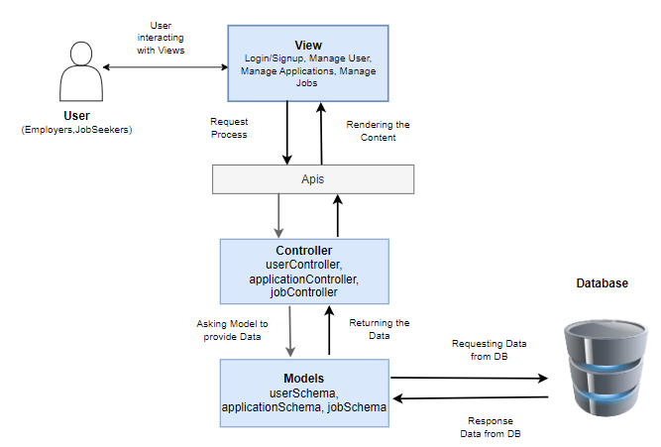

**Fig 4.1: Architectural Diagram**

This is our system architectural diagram which is based on MVC pattern. It has view which can also called front-end, Controllers which focus on managing the information for the system and Models contains underlying data.

Models contain user Schema, it has all the data related to user like name, email, password and role (employer/job seekers). It also has the logic like user’s password hashing and Jsonwebtoken (jwt). Application Schema contains name, email, cover letter, phone, address, resume, applicant ID and employer ID. Job Schema contains title, description, category, country, and city and salary range.

##### DETAILED DESIGN

##### 4.3.1 Use Case Diagrams

* + - 1. User(employers, job seekers) Registration and Authentication Use Case Diagram

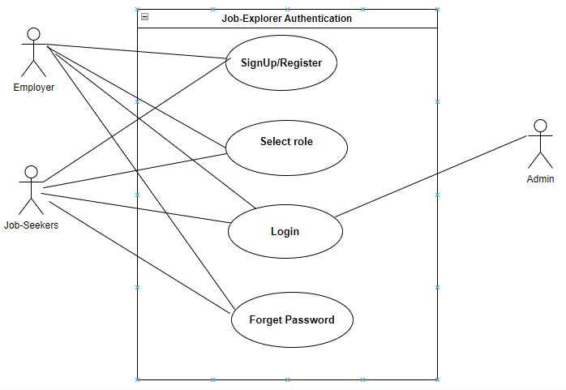

**Fig 4.2: User Registration and Authentication Use Case Diagram**

4.3.1.2 Dashboard Use-Case Diagram:

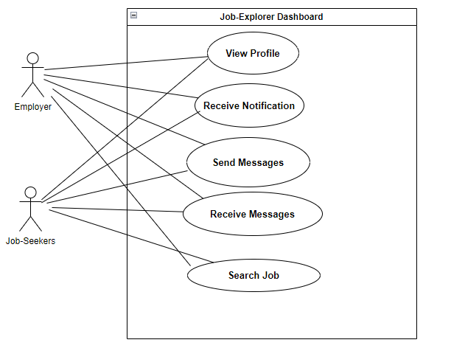

**Fig 4.3: User Dashboard Use Case Diagram**

* + - 1. Recommendation and Personalization Use Case Diagram

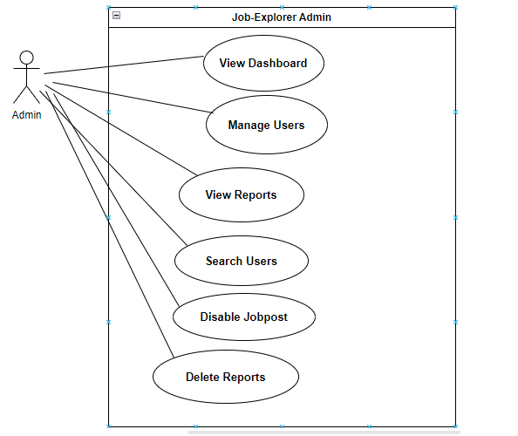

**Fig 4.3: Recommendation and Personalization Use Case Diagrams**

* + - 1. Profile Management Use Case Diagram

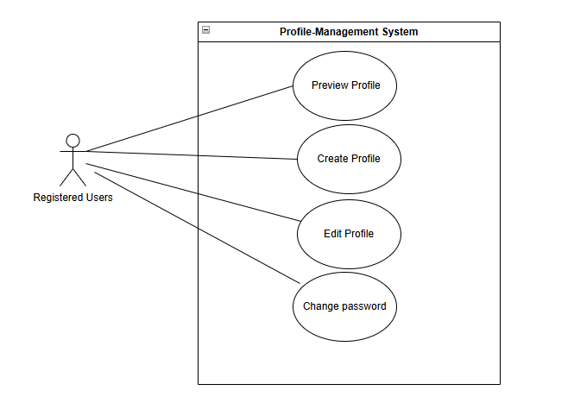

**Fig 4.4: profile Management Use Case Diagram**

* + - 1. Job Listing and posting Use Case Diagram

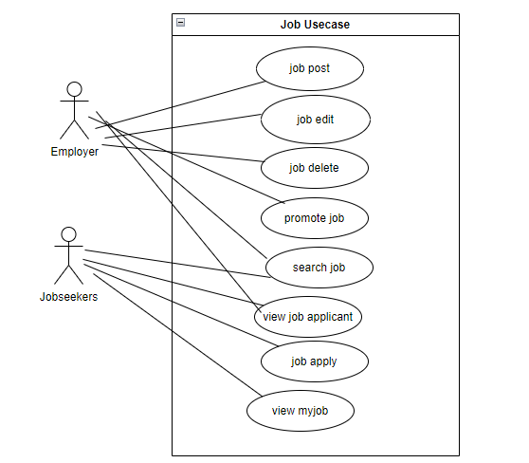

**Fig 4.5: job Listing and posting Use Case Diagram**

* + - 1. Job search and Filtering Use Case Diagram

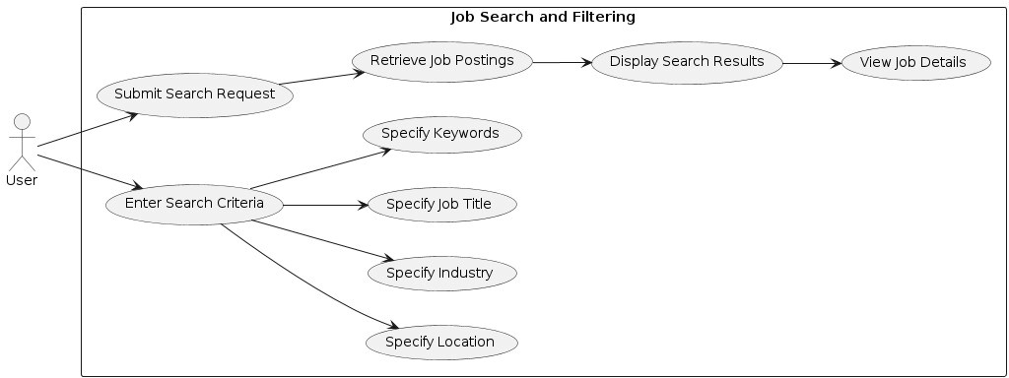

**Fig 4.6: job search and Filtering Use Case Diagram**

* + - 1. Communication and Messaging Use Case Diagram

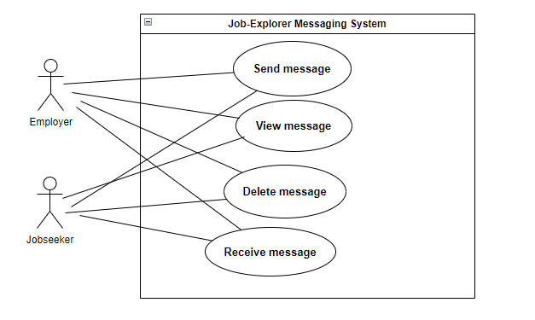

**Fig 4.7: Messaging Use Case Diagram**

* + - 1. Application Management Use Case Diagram

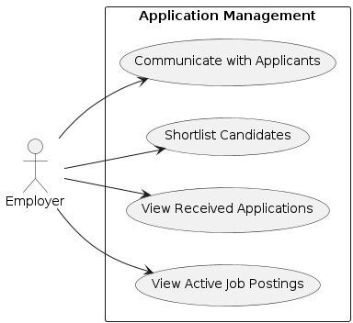

**Fig 4.8: Application Management Use Case Diagram**

* + - 1. Application Submission and tracking Use Case Diagram

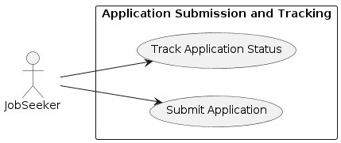

**Fig 4.9: Application Submission and tracking Use Case Diagram**

4.1.1.1 Job Explorer system Use Case Diagram

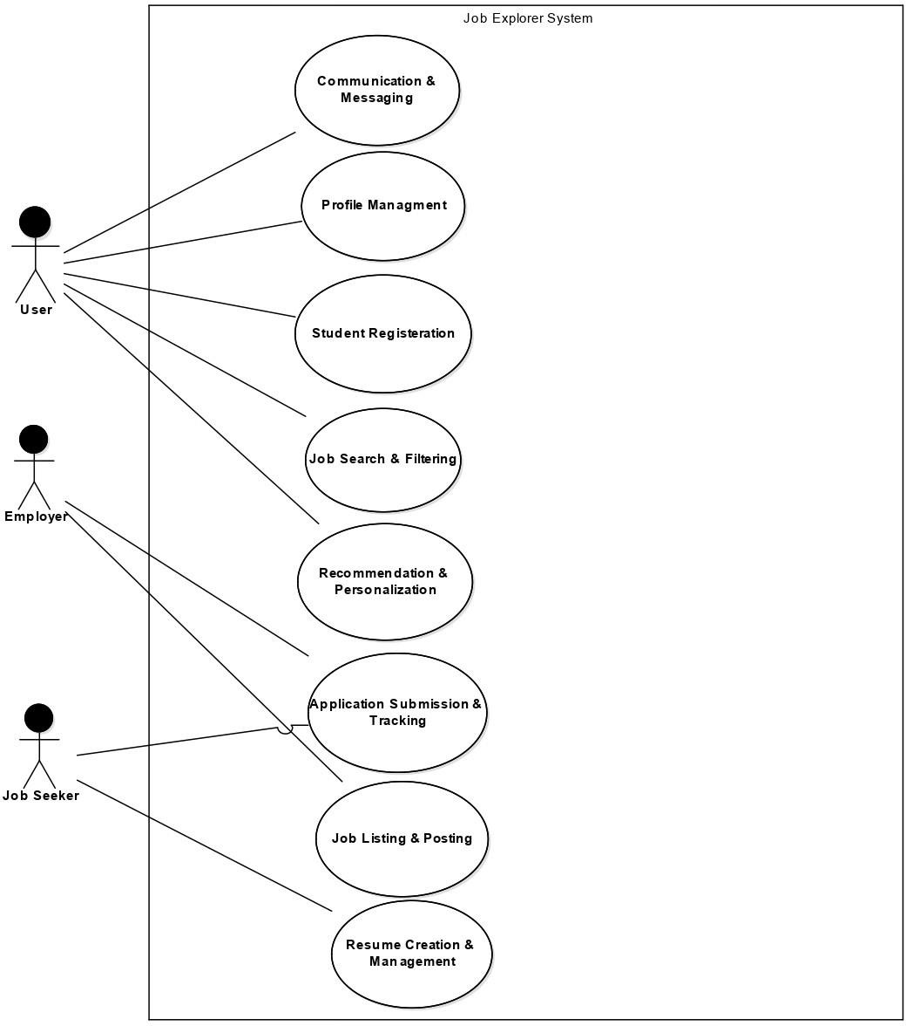

**Fig 4.10: Job Explorer system Use Case Diagram**

##### Fully Dressed Use Cases

* + - 1. Authentication

User Registration and Authentication

**Table 3.26: User Registration and Authentication Fully Dressed Use Case**

|  |  |
| --- | --- |
| **Use Case ID** | 001 |
| **Use Case** | User Registration and Authentication |
| **Actors** | Employer, Job seekers |

|  |  |  |  |
| --- | --- | --- | --- |
| **Description** | | User wants to create an account. | |
| **Preconditions** | | The user visits the job portal and navigates to the registration page. Such as a full name, email address, and password. | |
| **Post**  **Conditions** | | User successfully registers for an account and is authenticated to access the platform. | |
| **Basic Flow** | | 1. User accesses the job portal platform. 2. User selects the option to register for a new account. 3. System presents the user with a registration form. 4. User fills out the form with accurate information. 5. System validates the information. | 1. If valid, system creates a new user account and stores information. 2. System sends confirmation email to user's provided email address. 3. User receives email and verifies their account. 4. User can log in to the platform. |
| **Alternate Flow** | **Existing User:**  Can choose to log in instead of registering.  **Invalid Registration Information**: System prompts user to correct errors. | | **Email Verification Failure:** User can request new confirmation email or contact support. |

* + - * 1. Job searching and Filtering

**Table 3.27: job search and Flittering Fully Dressed Use Case**

|  |  |
| --- | --- |
| **Use Case ID** | 002 |
| **Use Case** | Job search and Filtering |

|  |  |  |
| --- | --- | --- |
| **Actors** | User | |
| **Description** | The process of searching for job opportunities and filtering search results on the job portal platform. | |
| **Preconditions** | User must be registered and authenticated on the platform. | |
| **Post**  **Conditions** | User receives a list of job postings matching the search criteria and can further refine or view details of specific job postings. | |
| **Basic Flow** | 1. User accesses the job portal platform and navigates to the job search section. 2. System presents the user with a search interface. 3. User inputs desired search criteria. | 1. System retrieves matching job postings from the database. 2. System displays search results to the user. 3. User reviews results and may refine search criteria. |
|  | 4. User submits the search request. | 8. If interested in a job, user clicks to view detailed information. |
|  |  | 9. System presents detailed job description. |
|  |  | 10. User decides to apply for the job. |
| **Alternative** | **Invalid Search Criteria**: System displays error message and prompts user to correct input.  **No Matching Results:** System informs user and provides suggestions for refining search |  |
| **Flow** |  |
|  | **Filtering Results:** User can further filter results based on additional criteria. |
|  | **Saved Searches**: System may offer option to save search criteria for future use. |

* + - * 1. Job listing and posting

**Table 3.28: job listing and posting Fully Dressed Use Case**

|  |  |  |
| --- | --- | --- |
| **Use Case ID** | 003 | |
| **Use Case** | Job listing and posting | |
| **Actors** | Employer | |
| **Description** | The process of searching for job opportunities and filtering search results on the job portal platform. | |
| **Preconditions** | Job listing is successfully created and published on the platform. | |
| **Post**  **Conditions** | Employer must be registered and authenticated on the platform. | |
| **Basic Flow** | 1. Employer accesses the job portal platform and navigates to the job posting section. 2. System presents employer with a job posting form. 3. Employer fills out the job posting form with relevant information. 4. System validates the information provided. | 1. If valid, system creates a new job listing and stores it in the database. 2. Job listing is published on the platform and made visible to job seekers. 3. Employer receives confirmation message indicating successful posting**.** |
| **Alternate Flow** | **Invalid Information**: System prompts employer to correct errors **Editing Job Listing:** Employer can edit listing to update information.  **Removing Job Listing**: Employer can remove job listing from platform. **Extending Deadline:** Employer can  Update job listing with new deadline. | **Removing Job Listing:** Employer can remove job listing from platform  **Extending Deadline:**  Employer can update job listing with new deadline |

* + - * 1. Resume creation and management

**Table 3.29: Resume creation and Management Fully Dressed Use Case**

|  |  |  |
| --- | --- | --- |
| **Use Case ID** | 004 | |
| **Use Case** | Resume creation and Management | |
| **Actors** | Job seeker | |
| **Description** | The process of creating, uploading, and managing resumes on the job Explorer platform. | |
| **Preconditions** | Job seeker must be registered and authenticated on the platform. | |
| **Post**  **Conditions** | Job seeker's resume is successfully created, uploaded, and managed on the platform. | |
| **Basic Flow** | 1. Job seeker accesses the job portal platform and navigates to the resume management section. 2. System presents job seeker with options to create a new resume or upload an existing one. 3. If creating a new resume, job seeker fills out resume form with personal information, education background, work experience, skills, etc. 4. If uploading an existing resume, job seeker selects file from device and uploads it to platform | 1. System validates resume information provided by job seeker. 2. Once resume is created or uploaded, job seeker can view and manage it on the platform. 3. Job seeker can edit and update resume information as needed. 4. Job seeker can format resume according to predefined templates or customize layout. |
| **Alternate Flow** | **Invalid Information:**  System prompts job seeker to correct errors.  **Uploading Different Formats:** System may support various file formats for resume uploads. | **Resume Versioning:** Job seeker may maintain multiple versions of their resume on the platform. |

* + - * 1. Application submission Tracking

**Table 3.10: Application submission Tracking Fully Dressed Use Case**

|  |  |  |
| --- | --- | --- |
| **Use Case ID** | 005 | |
| **Use Case** | Application submission and Tracking | |
| **Actors** | Job seeker Employer | |
| **Description** | The process of job seekers submitting applications and tracking their status, and employers managing received applications on the job portal platform. | |
| **Preconditions** | Job seeker must be registered and authenticated on the platform. Job posting must be active and available on the platform. | |
| **Post**  **Conditions** | Job seeker's application is successfully submitted to the employer.  Job seeker can track the status of their application on the platform. Employer receives and reviews the job seeker's application. | |
| **Basic Flow** | **Job seeker**   1. Job seeker accesses job listing and reviews details. 2. Job seeker decides to apply and selects the option to submit an application. 3. System presents job seeker with application form or prompts them to upload documents. 4. Job seeker fills out form or uploads documents. 5. Job seeker reviews application. 6. Job seeker submits application. 7. System confirms successful submission. | **Employer**   1. Employer accesses job postings section. 2. System presents list of active job postings and associated applications. 3. Employer selects specific job posting. 4. System displays list of received applications. 5. Employer reviews applications, shortlists candidates, and manages recruitment process. |
| **Alternate Flow** | **Incomplete Application**: System prompts job seeker to provide missing information | **Application Deadline**: System notifies job seeker if application is submitted after deadline.  **Application Withdrawal:** Job seeker may withdraw application. |

* + - * 1. Communication and Messaging

**Table 4.1: communication and Messaging Fully Dressed Use Case**

|  |  |  |
| --- | --- | --- |
| **Use Case ID** | 006 | |
| **Use Case** | Communication and Messaging | |
| **Actors** | User  Job seeker  Employer | |
| **Description** | The process of users, including job seekers and employers, communicating with each other through messaging on the job portal platform. | |
| **Preconditions** | User must be registered and authenticated on the platform. | |
| **Post Conditions** | Users can exchange messages with other users on the platform. | |
| **Basic Flow** | 1. User accesses the job portal platform and navigates to the messaging section. 2. System presents user with messaging interface displaying message inbox, sent messages, and options to compose new messages. 3. User selects message thread or composes new message. 4. If composing new message, user enters recipient's username or selects from list of contacts. | 1. User writes message in composition field. 2. User reviews message. 3. Once satisfied, user sends message. 4. Recipient receives message in their inbox. 5. Both sender and recipient can continue conversation by exchanging additional messages. |

|  |  |  |
| --- | --- | --- |
| **Alternate Flow** | **Message Filtering:**  Users may filter messages based on criteria such as sender, date, or content.  **Message Notification**: System may send notifications to users for new messages or updates to existing threads | **Blocking Users**: Users may block or report other users for unwanted or inappropriate messages. |

* + - * 1. Profile Management

**Table 4.2: profile Management Fully Dressed Use Case**

|  |  |
| --- | --- |
| **Use Case ID** | 007 |
| **Use Case** | Profile Management |
| **Actors** | User |
| **Description** | The process by which users can manage their profiles on the job portal platform, including updating personal information, adjusting privacy settings, and maintaining a professional online presence. |

|  |  |  |
| --- | --- | --- |
| **Preconditions** | User must be registered and authenticated on the platform. | |
| **Post Conditions** | User's profile information is successfully updated and saved on the platform. | |
| **Basic Flow** | 1. User accesses the job portal platform and navigates to the profile management section. 2. System presents user with options to view and edit their profile information. 3. User selects option to edit their profile. | 1. System displays user's profile information. 2. User updates desired fields. 3. User reviews updated profile information. 4. Once satisfied, user saves changes to their profile. 5. System confirms successful update and provides confirmation message to user. |
| **Alternate Flow** | **Privacy Settings:**  Users may adjust privacy settings for their profile.  **Profile Visibility:**  Users may choose to make their profiles public or private. | **Profile Picture:**  Users may upload a profile picture. |

* + - * 1. Recommendation and Personalization

**Table 4.3: Edit Recommendation and Personalization Fully Dressed Use Case**

|  |  |  |
| --- | --- | --- |
| **Use Case ID** | 008 | |
| **Use Case** | Recommendation and Personalization | |
| **Actors** | User | |
| **Description** | The process by which the job portal platform provides personalized job recommendations and content to users based on their preferences, activity, and profile information. | |
| **Preconditions** | User must be registered and authenticated on the platform.  User's profile information and activity history are available on the platform. | |
| **Post**  **Conditions** | User receives personalized job recommendations and content tailored to their interests and preferences. | |
| **Basic Flow** | 1. User accesses the job portal platform and navigates to the recommendations or personalized content section. 2. System analyzes user's profile information, including job preferences, skills, experience, and activity history. 3. Based on user's profile and activity history, system generates personalized job recommendations and content. | 1. User views personalized recommendations and content. 2. User interacts with recommendations by exploring job listings, reading articles, or taking recommended actions. 3. System continues to track user's activity and preferences, refining future recommendations and content. |
| **Alternate Flow** | **Feedback Loop:** Users may provide feedback on relevance and usefulness of recommendations and content, improving future personalization efforts beyond initial suggestions**.** | **Preference Adjustment:**  Users may adjust preferences or interests over time, prompting system to update recommendations accordingly**.**  **Exploration:**  Users may explore additional recommendations or content. |

* + - * 1. Application Management

**Table 4.4: Application Management Fully Dressed Use Case**

|  |  |  |  |
| --- | --- | --- | --- |
| **Use Case ID** | 009 | |  |
| **Use Case** | Application Management | |  |
| **Actors** | Employer | |  |
| **Description** | The process by which employers manage received job applications for posted job listings on the job portal platform, including reviewing, shortlisting, and communicating with applicants. | |  |
| **Preconditions** | Employer must be registered and authenticated on the platform.  There must be active job postings on the platform to receive applications. | |  |
| **Post**  **Conditions** | Employer successfully manages received job applications, including reviewing, shortlisting, and communicating with applicants as needed. | |  |
| **Basic Flow** | 1. Employer accesses the job portal platform and navigates to the application management section. 2. System presents employer with list of active job postings and associated applications 3. Employer selects specific job posting to view received applications. | 1. System displays list of job seeker applications for selected job posting 2. Employer reviews applications. 3. Employer may choose to shortlist candidates or reject applicants 4. Employer communicates with selected candidates, schedules interviews, and manages recruitment process. |  |

##### Activity Diagrams:

* + 1. **Admin Activity Diagram**

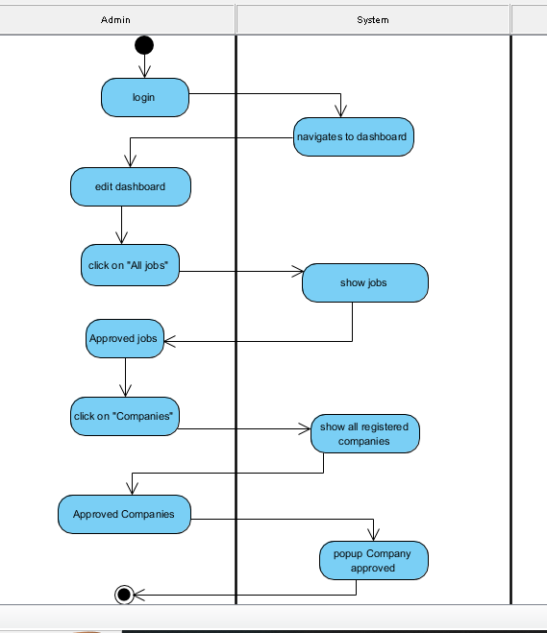

**Fig 4.10:** **Admin Activity Diagram**

##### Job Seeker Activity Diagram

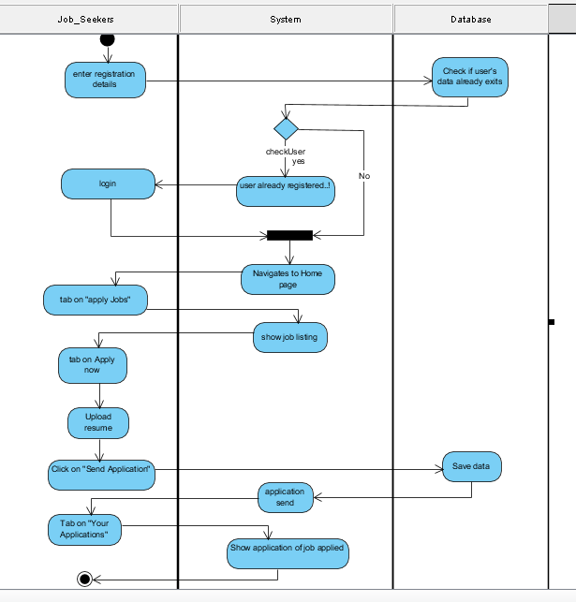

**Fig 5.2:** **Job Seeker Activity Diagram**

##### Employers Activity Diagram

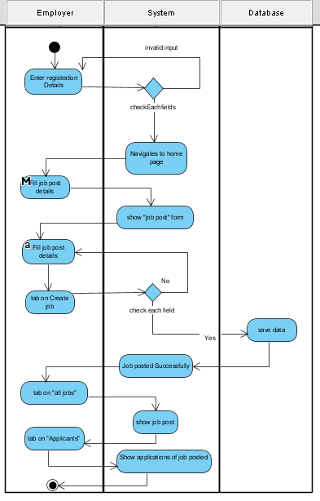

**Fig 5.3:** **Employers Activity Diagram**

##### 4.1 DATABASE DESIGN

**4.1.1** **Schema Diagram**

Schema diagram helps to understand the database structure. It shows data in the form of tables.

##### Schema Diagram:

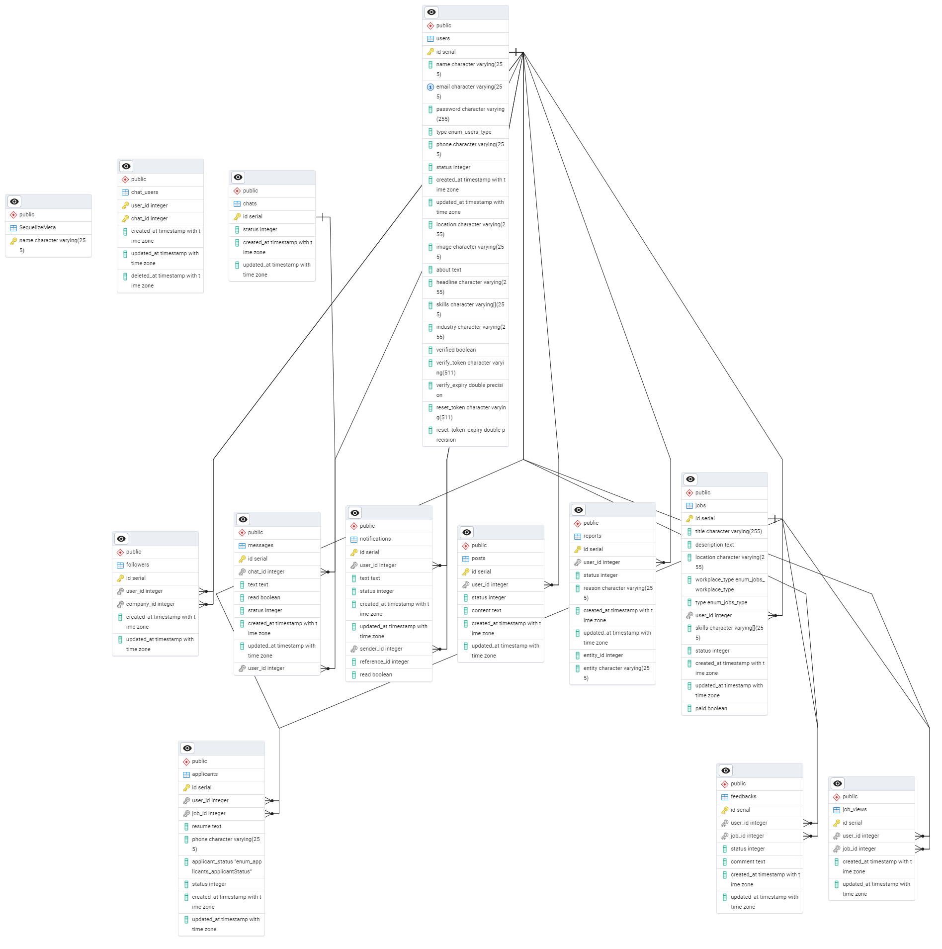

* + - 1. Data Dictionary

**Fig 4.10: Schema Diagram**

A database schema is the description of the data in the database. Here is all the tables and views with in a schema.

##### Collection/Tables:

Users:

* + - * + _id (Object ID): Unique identifier for each user and it will also a primary key.
        + name: User’s name in String
        + email: User’s email address in String data type
        + Password: Hashed password for security.
        + Role: “jobseeker” or “employer”.
        + Created At: Time when user was first created. Jobs:
        + _id (Object ID): Unique identifier for each job posting and it will also a primary key.
        + title: Job title
        + Description: Detailed description of job.
        + Category: Hashed password for security.
        + City: City name in String.
        + Location: Complete location in String.
        + Fixed Salary: Offered salary in Numbers.
        + Expired: if job has been expired, returns Boolean.
        + Posted By: Object ID, reference to user document (employer) who posted the job.
        + JobPostedOn: Time when job was first created. Applications:
        + _id (Object ID): Unique identifier for each application and it will also a primary key.
        + Job: Reference to the job document the application is for.
        + Name: jobseeker’s name in String.
        + email: jobseeker’s email address in String data type
        + resume: jobseeker’s email address in String data type
        + Application Date: Hashed password for security.
        + Created At: Time when user was first created.

# Chapter 5: Implementation

### Chapter 5

#### IMPLEMENTATION

##### 5.1 ENDEAVOR (TEAMWORK + WORK + WAY OF WORKING)

##### Team

* Farman khan 22522
* Saud Akbar 22661
* Shahzaib Ishaq 30041

5.1.1.1 WBS

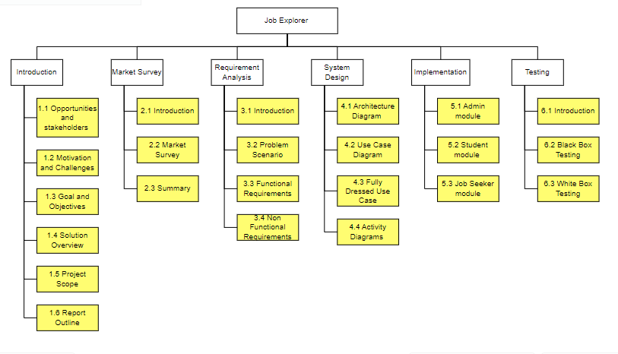

**Fig 5.1: Work Breakdown Structure**

##### Roles & Responsibility Matrix

**Table 4.5: Roles & Responsibility Matrix**

|  |  |  |  |
| --- | --- | --- | --- |
| **WBS #** | **WBS Deliverable** | **Activity to Complete the Deliverable** | **Responsible Team Member(s)**  **& Role(s)** |
| 1.1 | Final Documentation Introduction | Project proposal | Farsan khan Shahzaib Ishaq  Saud Akbar |

|  |  |  |  |
| --- | --- | --- | --- |
| 1.2 | Literature / Markey Survey | We visit many related online platforms such link din, Rozee.pk. | Farsan khan Shahzaib Ishaq  Saud Akbar |
| 1.3 | Requirements Analysis | Finalizing the Requirements | Farsan khan Shahzaib Ishaq  Saud Akbar |
| 1.4 | System Design | Use Case Diagram, Activity Diagram, Architecture Diagram,  Data Base Schema Diagram | Farsan khan  Shahzaib Ishaq  Saud Akbar |
| 1.5 | Frontend Implementation | Web Application Code | Farsan khan  Shahzaib Ishaq  Saud Akbar |
| 1.6 | Testing and performance evaluation | Evaluating System Performance Against Test Cases | Farsan khan  Shahzaib Ishaq  Saud Akbar |

##### Way of Working

|  |  |
| --- | --- |
| **No.** | **Way of Working** |
| **1** | Tools for team collaboration: Zoom  Whatsapp Group |
| **2** | Task Allocation:  We create a to do list and assign tasks to each member of the team as per the guidance of supervisor. |
| **3** | Distributed version control and source code management functionality:   * GitHub * Visual Studio |

* 1. **COMPONENTS, LIBRARIES, WEB SERVICES, AND STUB****S**
     + - HTML
       - CSS
       - React.js
       - Express js
       - Postgresql dB
       - Nodejs

##### IDE, TOOLS, AND TECHNOLOGIES

* + - * Visual Studio code
      * HTML
      * CSS
      * React.js
      * Express js
      * Mongo dB
      * Node JS

##### BEST PRACTICES / CODING STANDARDS

Here are some best practices that are followed:

##### Software Engineering Practices

We use waterfall method for the best engineering practices as this method is a sequential development process

* Analysis
* Design
* Implementation
* Testing

##### Development Practices & Standards

* + - * **Code Simplicity:** we try to Keep the simple code to reduce the complexity in development
      * **Testing:** Ensure the working of all component as expected by keeping end to end continuously testing
      * **Code Coherence:** While collaborating with our team we have a clear style guide for the codebase.

##### DEPLOYMENT ENVIRONMENT

**6.5.1** **Deployment Diagram**

# Chapter 6: Testing & Evaluation

##### INTRODUCTION

**TESTING & EVALUATION**

The fundamental purpose of Test & Evaluation (T&E) is to provide knowledge to assist in Risk Management that is involved in developing, producing, operating, and sustaining systems and capabilities. The T&E process is an integral part of the Systems Engineering Process (SEP) which identifies levels of performance and assists the developer in correcting deficiencies. In Testing, we can check our system against Specified Requirements. Testing aimed at breaking the system i.e. finding all the possible errors and scenarios in which system can possibly fail. Development of system is a human action so it is not possible to develop totally error free system. However, errors can be minimized to a lesser rate by doing proper testing. This chapter is about on testing and evaluation of the system. We use Equivalence Partition Testing technique of black box testing.

##### LIST OF TEST SCENARIOS

**Create Account**

**Input:** Username, password, Email

**Test Data:**

|  |  |  |
| --- | --- | --- |
| **Input name** | **Valid** | **Invalid** |
| Username | {{a, b, c …z}, {A, B, C …Z},  “”}  Alphanumeric include special characters (@, - ,_, +) | Arithmetic Symbols  Special character other than valid |
| password | {{a, b, c …z}, {A, B, C  …Z},[0,.,.,.,.,.,,9], Password length  >= 8 && Password length <= 30} | Empty  Other than valid  Password length <= 8 && Password length >= 30 |
| Email | Contains ‘@’ along with  {{a, b, c ......... z}, {A, B, C…Z}, {1,2,3…}} before  ‘@’ | Not contains ‘@’  Multiple ‘@’ characters  Special characters except ‘@’ |
|  | {. _, -} before ‘@’ Ending ‘.’ |  |

**Table: 4.6 Sign-Up**

**Valid Class**

|  |  |  |  |  |  |
| --- | --- | --- | --- | --- | --- |
| **Id** | **Input field name** | **Input** | **ECP** | **Expected**  **Output** | **Actual Output** |
| **01** | Username | farsankhan | {{a, b, c …z}, {A, B, C  …Z}, “”}  Alphanumeric include | Valid | Ok |
| Password | 62582789 | {{a, b, c …z}, {A, B, C  …Z},[0,.,.,.,.,.,,9], Password length >= 8 && Password length <= 30} | Valid | Ok |
| Email | farsan@gmail.com | {{a, b, c …z}, {A, B, C …Z},[0,.,.,.,.,.,,9], Password length >= 8 && Password length <= 25} | Valid | Ok |
|  | farsan@gmail.com | Contains ‘@’ along with  {{a, b, c ......... z}, {A, B,  C…Z}, {1,2,3…}} before  ‘@’  {., _, -} before ‘@’ Ending  ‘.’ | Valid | Ok |

**Invalid Class**

|  |  |  |  |  |  |  |
| --- | --- | --- | --- | --- | --- | --- |
| **Id** | **Input field name** | **Input** | **ECP** | | **Expected**  **Output** | **Actual Output** |
| **01** | Username | farsan@2 | * Arithmetic Symbols * Special character other than valid | | Invalid | Ok |
| **01** | Password | kavf$ | * • | Empty  Other than valid  Password length <= 8  && Password length  >= 35 | Invalid | Ok |
| Email | farsan@gmail  @.com |  | Not contains ‘@’  Multiple ‘@’ characters  Special characters except  ‘@’  Not ending at ‘.’ With 3-4 letters | Invalid | Ok |

**Login Account**

**Input:** Username, password

**Test Data:**

|  |  |  |
| --- | --- | --- |
| **Input name** | **Valid** | **Invalid** |
| Email | * Contains ‘@’ along with * {{a, b, c ......... z}, {A, B, * C…Z}, {1,2,3…}} before * ‘@’ * {., _, -} before ‘@’ Ending ‘.’ | * Not contains ‘@’ * Multiple ‘@’ characters * Special characters except   ‘@’   * Not ending at ‘.’ With 3-4   letters |
| Password | • {{a, b, c …z}, {A, B, C  …Z},[0,.,.,.,.,.,,9], Password length  >= 8 && Password length <= 35} | * Empty * Other than valid * Password length <= 8 &&   Password length >= 35 |

**Table: 4.7 Login**

**Test Case**

**Valid Class**

|  |  |  |  |  |  |
| --- | --- | --- | --- | --- | --- |
| **Id** | **Input field name** | **Input** | **ECP** | **Expected**  **Output** | **Actual Output** |
| **02** | Email | farsan@gmail.com | * Contains ‘@’ along with • {{a, b, c ......... z}, {A, B,   C…Z}, {1,2,3…}} before   * ‘@’ * {., _, -} before ‘@’ Ending ‘.’ | Valid | Ok |
| Password | 62582789 | • {{a, b, c …z}, {A, B, C …Z},[0,.,.,.,.,.,,9], Password length >= 8 && Password length <= 25} | Valid | Ok |

**Invalid Class**

|  |  |  |  |  |  |
| --- | --- | --- | --- | --- | --- |
| **Id** | **Input field name** | **Input** | **ECP** | **Expected**  **Output** | **Actual Output** |
| 01 | Email | farsan@gmai l@.com | * Not contains ‘@’ ●   Multiple ‘@’ characters   * Special characters except ‘@’ Not ending at ‘.’ With 3-4   letters | Invalid | Ok |
| 02 | Password | kavf$ | * Empty * Other than valid * Password length <= 8   && Password length  >= 25 | Invalid | Ok |

**Verify Account**

**Input:** user name, Email,

**Test Data:**

|  |  |  |
| --- | --- | --- |
| **Input name** | **Valid** | **Invalid** |
| username | {{a, b, c …z}, {A, B, C …Z}} | * Arithmetic Symbols * Alphanumeric include * Special character other than valid |
| Email | * Contains ‘@’ along with * {{a, b, c ......... z}, {A, B,   C…Z}, {1,2,3…}} before  ‘@’  {., _, -} ‘@’ ‘.’ ‘@’   * {., _, -} ‘@’ ‘.’ | * Not contains ‘@’ * Multiple ‘@’ characters * Special characters except ‘@’   Not ending at ‘.’ With 3-4 letters |

**Test Case**

**Valid Class**

|  |  |  |  |  |  |
| --- | --- | --- | --- | --- | --- |
| **Id** | **Input field name** | **Input** | **ECP** | **Expected**  **Output** | **Actual Output** |
| **03** | username | farsan | ● {{a, b, c …z},  {A, B, C  …Z}} | Valid | Ok |
| Email | farsanl@gmail.com | * Contains ‘@’   along with   * {{a, b, c .........   z}, {A, B, C…Z}, {1,2,3…}} before  ‘@’   * {., _, -} before   ‘@’ Ending ‘.’ | Valid | Ok |

**Invalid Class**

|  |  |  |  |  |  |
| --- | --- | --- | --- | --- | --- |
| **Id** | **Input field name** | **Input** | **ECP** | **Expected**  **Output** | **Actual Output** |
| **03** | username | farsan | * Arithmetic Symbols * Alphanumeric include * Special character other than valid | Invalid | Ok |
|  | Email | farsan@g mail@.co m | * Not contains ‘@’ * Multiple ‘@’ characters * Special characters except ‘@’ Not ending at ‘.’ With 3-4 letters | Invalid | Ok |

##### NON-FUNCTIONAL REQUIREMENTS TEST CASES

##### Performance Requirements

##### Reliability Requirements

Loader.io report

##### SUMMARY

In this chapter we have provided list of test scenarios we have designed to evaluate our project. We have listed all the test data and test cases of the stakeholders involved in our system.

# Chapter 7: Conclusion & Outlook

#### CONCLUSION & OUTLOOK

##### INTRODUCTION

The Job Explorer project has been successfully developed, addressing the specific requirements identified during the analysis phase. The project report covered seven comprehensive chapters, providing a detailed account of the entire project lifecycle. In this chapter we will conclude our project report by discussing future work which needs to be done on this project and work which is completed.

##### ACHIEVEMENTS & IMPROVEMENTS

We have improved a lot as individuals and as teams as well. We learned about new technologies. With the help of our Supervisor, we have improved our way of thinking and working.

##### FUTURE RECOMMENDATIONS / OUTLOOK

We will try our best to increase awareness with our system “Online Job Explorer System”. We will keep updating the system with the passage of time and will bring in feasible changes that could help our system in positive way.

##### SUMMARY

We started the report with first chapter “Introduction” where we discussed opportunity and stakeholders along with motivation and goals. Then we did literature review of other systems and used certain requirement elicitation to gather requirements. We discussed fully dressed Use Cases and System Sequence Diagram along ERD and Flow of the system. Finally, we made test data and test cases of our system.

## References

Application. (n.d.). *HRR*. Retrieved from https://play.google.com/store/apps/details?id=com.homerentrecord

Commons, D. (2021). *Pakistan*. Retrieved from https://datacommons.org/place/country/PAK/?utm_medium=explore&mprop=cou nt&popt=Person&hl=en#

IEEE. (n.d.).*Terminology and Notation*. Retrieved from https://cmte.ieee.org/tcrts/education/terminology-and-notation/

Iqbal Institute Policy Studies. (n.d.). *Tenancy Rights in Pakistan: Here is What You Need to Know*. Retrieved from https://iips.com.pk/laws-and-regulations-tenancy-righ ts- in-pakistan-here- is-what-you-need-to-know/

Möckel, J.-M. (2022). *React Best Practices – Tips for Writing Better React Code in 2022*. Retrieved from freeCodeCamp: https://[www.freecodecamp.org/news/best](http://www.freecodecamp.org/news/best)- practices-for- react/

O'Neill, A. (2023, July 21). *Pakistan: Literacy rate from 2006 to 2019, total and by gender*

. Retrieved from https://[www.statista.com/statistics/572781/literacy-rate-](http://www.statista.com/statistics/572781/literacy-rate-) in- pakistan/ Quran. (36:82). His command is only when He intends a thing that He says to it, “Be,” and it is.

Website. (n.d.). National job portal <https://www.njp.gov.pk/>

Wikipedia. (2023, December 30). *Internet in Pakistan*. Retrieved from https://en.wikipedia.org/wiki/Internet_in_Pakistan

#### APPENDICES

##### APPENDIX-A: SOFTWARE REQUIREMENTS SPECIFICATIONS (SRS) APPENDIX-B: DESIGN DOCUMENTS

##### Gantt chart

##### Database Design

**APPENDIX****-C:** **CODING STANDARDS / CONVENTIONS** **APPENDIX****-D:** **TEST SCENARIOS**

##### APPENDIX-E: WORK BREAKDOWN STRUCTURE APPENDIX-F: ROLES & RESPONSIBILITY MATRIX APPENDIX-H: TECHNICAL DOCUMENTATION

##### Installation Guide

* + 1. Libraries & Dependencies

##### Troubleshooting Guide

##### Contact Information

* + 1. Farsan khan Phone: +92 3325028197

Email: [farsankhan1122@gmail.com](mailto:farsankhan1122@gmail.com)

* + 1. Shahzaib Ishaq Phone: +92 3245534060

Email: [shehkhan494@gmail.com](mailto:shehkhan494@gmail.com)

* + 1. Saud Akbar Phone: +92 3065939379 Email:22661@stude